SET 30
Mobile App Usage Analysis
Dataset: Mobile_App_Usage.csv
User_ID | Gender | Age | Screen_Time (hrs) | App_Usage_Count | Data_Used (GB) | Satisfaction | Usage_Date
U01 | Male | 20 | 4.5 | 18 | 2.4 | 3 | 2025-01-08
U02 | Female | 22 | 6.0 | 25 | 3.8 | 5 | 2025-01-08
U03 | Male | 19 | 3.2 | 12 | 1.6 | 3 | 2025-02-11
U04 | Female | 21 | 7.1 | 30 | 4.5 | 5 | 2025-02-11
U05 | Male | 23 | 2.8 | 10 | 1.2 | 2 | 2025-03-14
U06 | Female | 20 | 5.4 | 22 | 3.1 | 4 | 2025-03-14

1. Histogram and density plot of screen time
R Code

library(ggplot2)

mobile <- data.frame(
User_ID = c("U01", "U02", "U03", "U04", "U05", "U06"),
Gender = c("Male", "Female", "Male", "Female", "Male", "Female"),
Age = c(20, 22, 19, 21, 23, 20),
Screen_Time = c(4.5, 6.0, 3.2, 7.1, 2.8, 5.4),
App_Usage_Count = c(18, 25, 12, 30, 10, 22),
Data_Used = c(2.4, 3.8, 1.6, 4.5, 1.2, 3.1),
Satisfaction = c(3, 5, 3, 5, 2, 4),
Usage_Date = as.Date(c(
"2025-01-08", "2025-01-08",
"2025-02-11", "2025-02-11",
"2025-03-14", "2025-03-14"
))
)

ggplot(mobile, aes(x = Screen_Time)) +
geom_histogram(
aes(y = after_stat(density)),
bins = 5,
fill = "skyblue",
color = "black"
) +
geom_density(
color = "red",
linewidth = 1
) +
labs(
title = "Distribution of Mobile App Screen Time",
x = "Screen Time (hours)",
y = "Density"
) +
theme_minimal()

Output:
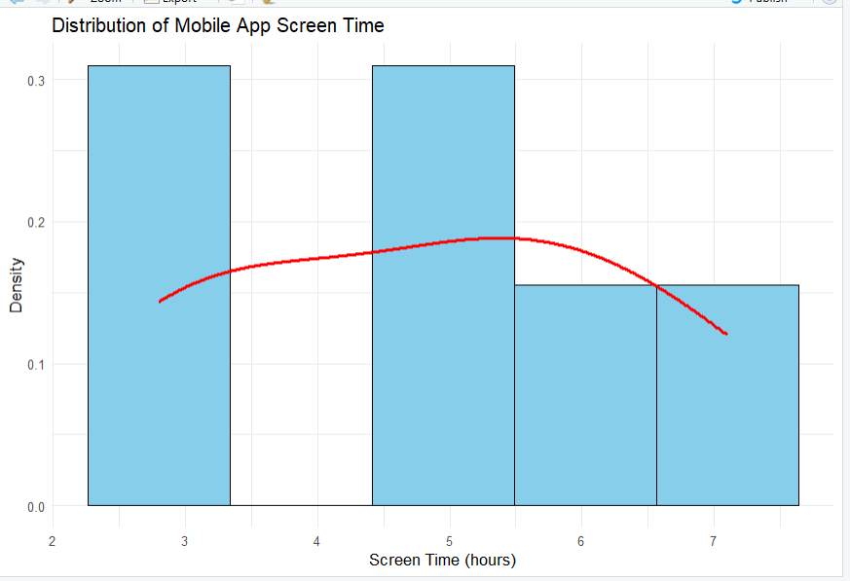
Result: Screen time ranges from 2.8 to 7.1 hours. The users have different usage levels, and the histogram with density curve shows the distribution. With only six observations, the distribution shape and potential outliers cannot be determined reliably.

2. Scatter plot of data used and screen time
R Code

library(ggplot2)

ggplot(mobile, aes(
x = Screen_Time,
y = Data_Used
)) +
geom_point(color = "blue", size = 4) +
geom_smooth(
method = "lm",
se = FALSE,
color = "red"
) +
labs(
title = "Screen Time vs Data Usage",
x = "Screen Time (hours)",
y = "Data Used (GB)"
) +
theme_minimal()
cor(mobile$Screen_Time, mobile$Data_Used)

Output:
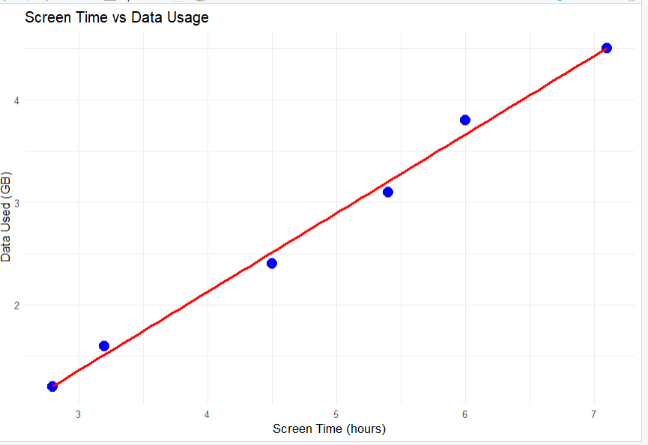
Result: Screen time and data usage have a strong positive correlation (approximately 0.99). Users with longer screen time generally consume more mobile data in this dataset.

3. Average satisfaction by gender
R Code

library(ggplot2)
library(dplyr)

satisfaction_avg <- mobile %>%
group_by(Gender) %>%
summarise(
Average_Satisfaction = mean(Satisfaction)
)

ggplot(satisfaction_avg, aes(
x = Gender,
y = Average_Satisfaction,
fill = Gender
)) +
geom_col(width = 0.6) +
geom_text(
aes(label = round(Average_Satisfaction, 2)),
vjust = -0.5
) +
labs(
title = "Average User Satisfaction by Gender",
x = "Gender",
y = "Average Satisfaction Score"
) +
theme_minimal()

Output:
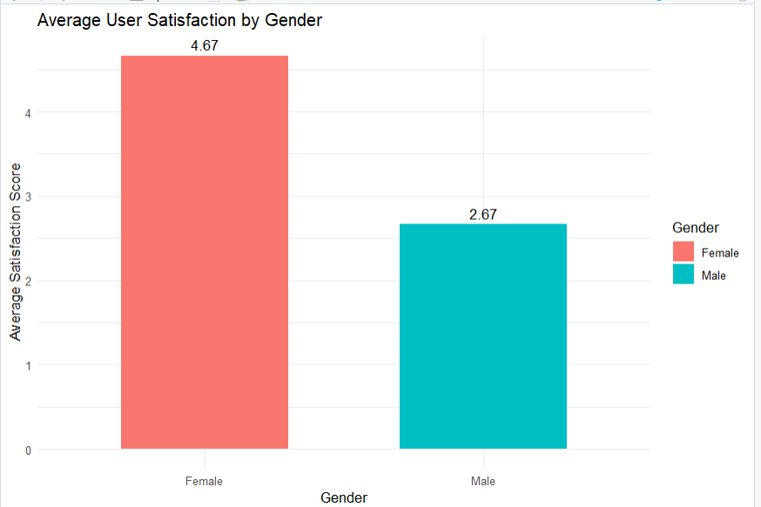
Result:
- Male average satisfaction: 2.67
- Female average satisfaction: 4.67
Female users have a higher average satisfaction score in this sample. Since there are only three users in each group, this should not be treated as a general conclusion about gender and satisfaction.
4. Interactive Tableau mini dashboard
Procedure (Tableau)
- Open Tableau and connect to Mobile_App_Usage.csv.
- Check that Usage_Date is recognized as a Date field and that Screen_Time, Data_Used, and App_Usage_Count are numeric.
- Create a bubble chart:
  - Drag Screen_Time to Columns.
  - Drag Data_Used to Rows.
  - Select Circle in the Marks card.
  - Drag Gender to Color.
  - Drag App_Usage_Count to Size.
  - Drag User_ID, Age, and Satisfaction to Tooltip.
- Create a line chart:
  - Drag Usage_Date to Columns.
  - Drag Screen_Time to Rows and choose the desired aggregation, such as Average.
  - Use Gender on Color to compare usage trends by gender.
- Add Gender and Usage_Date to Filters, then select Show Filter for both.
- Create a dashboard titled Mobile App Usage Dashboard and place the bubble chart, line chart, and filters together.

Output:
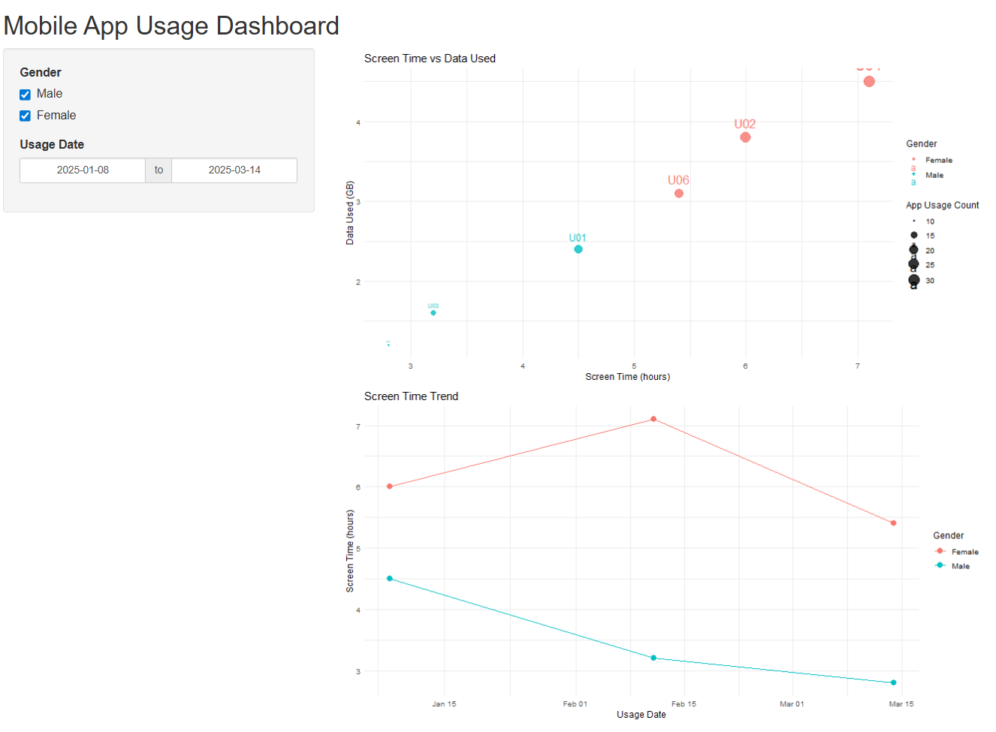
Result: The bubble chart shows that users with higher screen time generally use more data and open more apps. The line chart compares average screen time across the three dates for male and female users. Filters help users explore each gender and date range. Because the data has only three dates, the line chart shows a limited snapshot rather than a long-term trend.

